package com.prodapt.basics;

public class SchoolRecords {

String schoolName;

int schoolId;

String schoolAddress;

void addRecords () {

schoolName = "RPC Matric School";

schoolId = 123;

schoolAddress = "Infocity";

}

void displayRecords () {

System.out.println("The school name is "+schoolName);

System.out.println("The school Id is "+schoolId);

System.out.println("The school address is "+schoolAddress);

}

}

**Tester class**

package com.prodapt.basics;

public class Tester {

public static void main(String[] args) {

// TODO Auto-generated method stub

SchoolRecords sc = new SchoolRecords ();

sc.addRecords();

sc.displayRecords();

}

}

Output

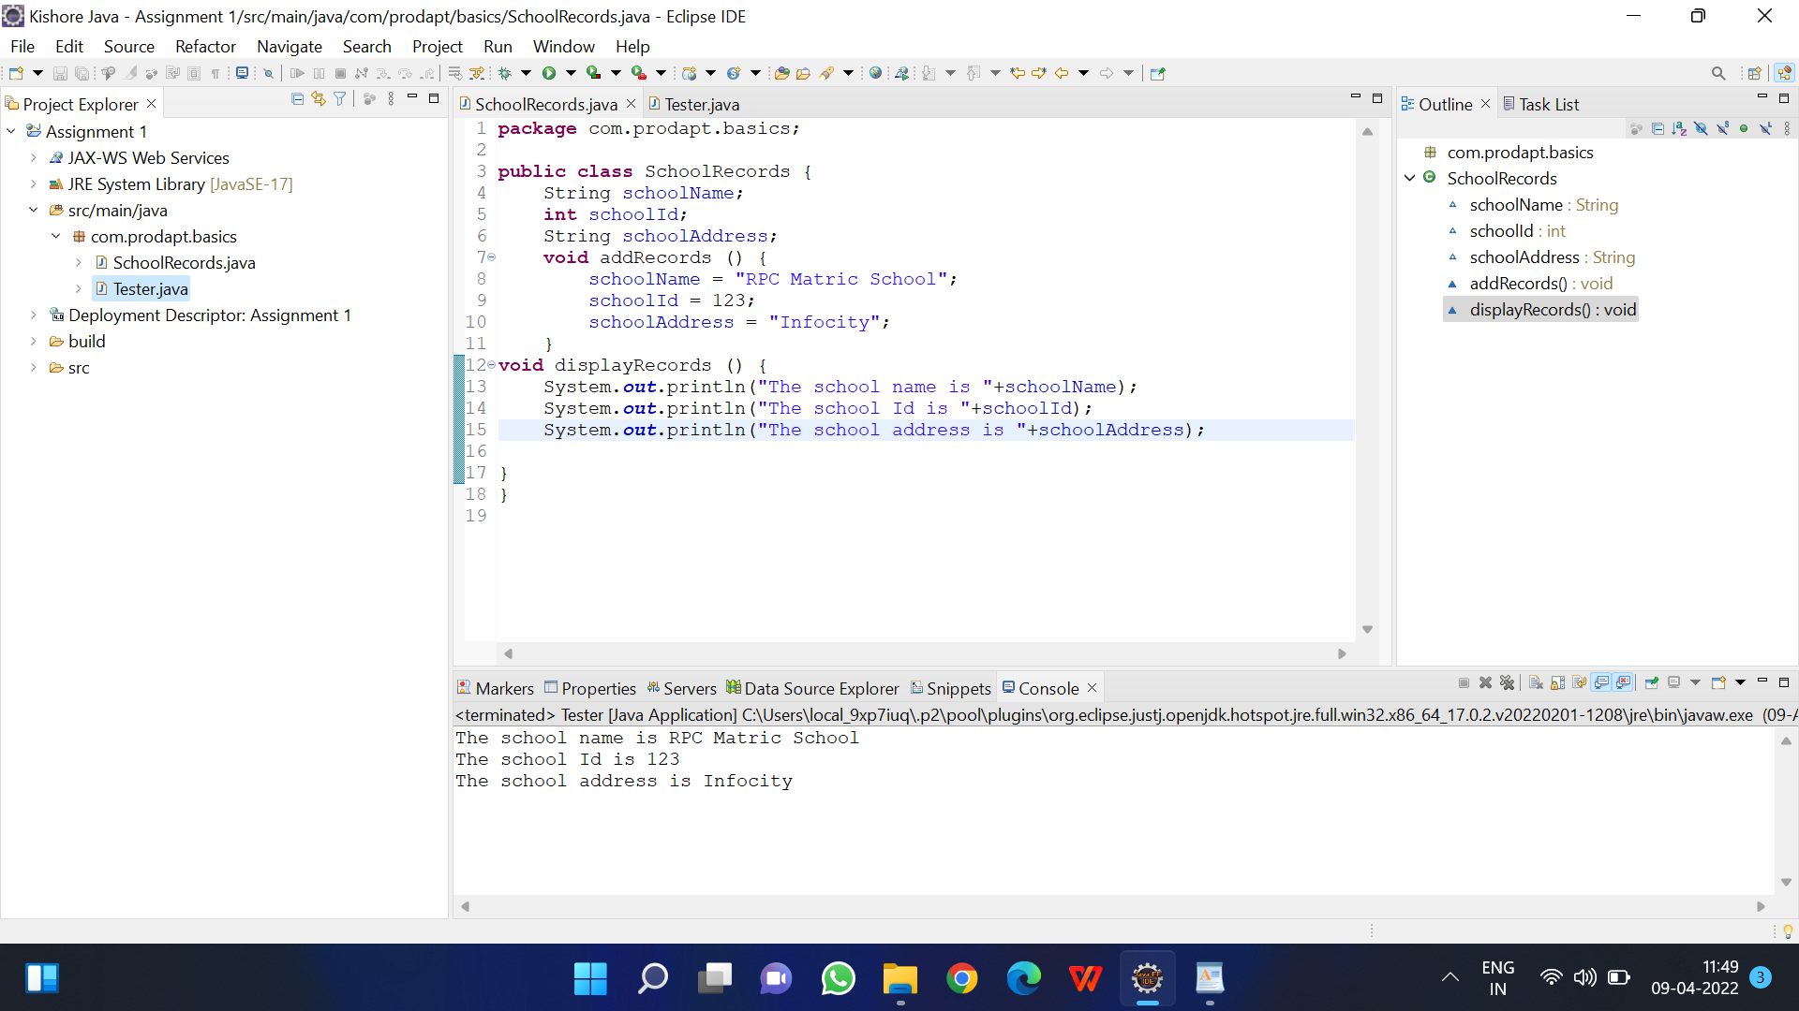

**SimpleIntrest**

package com.prodapt.basics;

public class SimpleIntrest {

public static int prinicipal = 1200;

public static int time_in_months = 2;

public static float rate = 5.66f;

public static void main(String[] args) throws Exception {

// TODO Auto-generated method stub

float si = (prinicipal * rate * time_in_months)/100;

System.out.println("the amount to be paid after the loan duratiopn ends is "+(prinicipal + si));

}

}

**Output**

